**DEEP LEARNING CASE STUDY**

R.Vivek - HU21CSEN0500298

K.Sridharani - HU21CSEN0500315

S.Harshita - HU21CSEN0500318

**Insights into Cardiac Wellness: Using CNNs for Predictive Heart Disease Analysis**

**1. Problem Statement:**

**Objective:** The objective of this case study is to develop a Convolutional Neural Network (CNN) model to predict heart disease based on medical attributes of patients.

**CHALLANGES:**

* **Data Quality:** Medical data often suffer from issues like missing values, outliers, and errors. Ensuring the quality and reliability of medical data is crucial for accurate predictions.
* **Feature Engineering:** Identifying and selecting relevant features from medical datasets can be challenging due to the complex nature of heart diseases. This involves domain knowledge and expertise in understanding which features are most indicative of heart disease.
* **Model Performance:** Achieving high accuracy and reliability in predicting heart disease is essential for clinical applications. Poor model performance could lead to incorrect predictions, potentially endangering patients' lives.

**APPLICATIONS:**

* Early Detection: Early detection of heart disease is crucial for timely intervention and treatment. CNN models can aid in identifying patterns in medical data that indicate the presence of heart disease, allowing for early diagnosis and intervention.
* Personalized Medicine: By analyzing patient data, CNN models can help in tailoring treatment plans for individual patients based on their risk factors. This personalized approach can lead to more effective treatment strategies and better patient outcomes.
* Remote Monitoring: CNN models deployed in remote monitoring systems can continuously assess patient health, alerting healthcare providers to potential heart disease risks. This proactive monitoring can help in preventing heart-related complications and improving overall patient care.

**2. CNN Analysis:**

**How CNN is Used:** CNNs are utilized in this case study to learn hierarchical representations of medical data, capturing spatial dependencies between input features. The architecture consists of convolutional layers followed by pooling layers to extract relevant features from input images of medical data.

**Architecture and Hyperparameter Tuning:**

* **Convolutional Layers:** These layers apply convolutional filters to the input data to detect various patterns and features. The number of filters and the size of the convolutional kernels are hyperparameters that need to be tuned.
* **Pooling Layers:** Pooling layers downsample the feature maps generated by the convolutional layers, reducing the spatial dimensions of the data while retaining important features. Common pooling methods include max pooling and average pooling.
* **Fully Connected Layers:** These layers take the output of the convolutional and pooling layers and perform classification tasks. They connect every neuron in one layer to every neuron in the next layer.
* **Activation Functions:** Rectified Linear Unit (ReLU) is commonly used as the activation function in convolutional layers to introduce non-linearity into the model.
* **Dropout:** Dropout layers may also be included to prevent overfitting by randomly dropping a percentage of neurons during training.

**Hyperparameters** like learning rate, batch size, number of filters, and kernel size are tuned using techniques like grid search or random search to optimize model performance.

**3. EXPERIMENTATION:**

**Google Colab/Github Code:**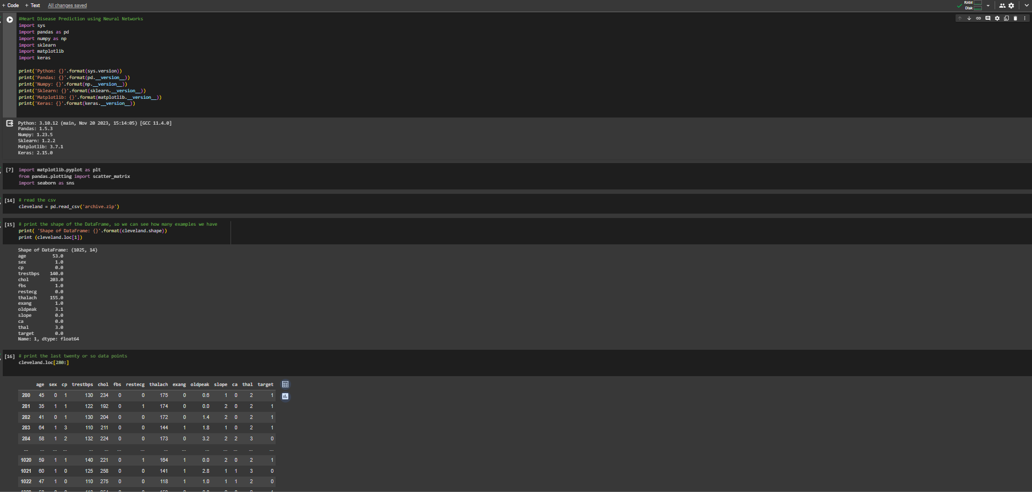

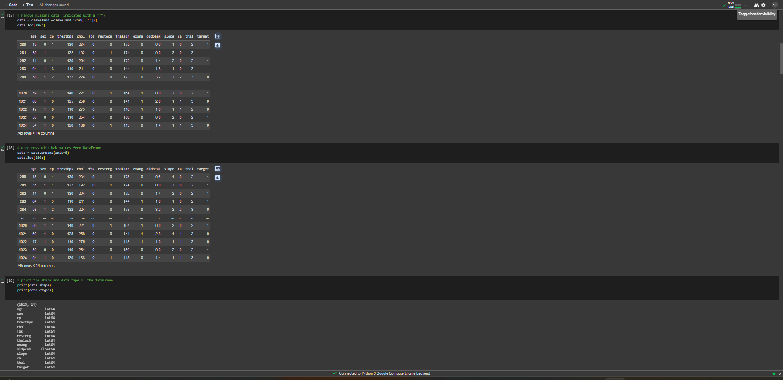

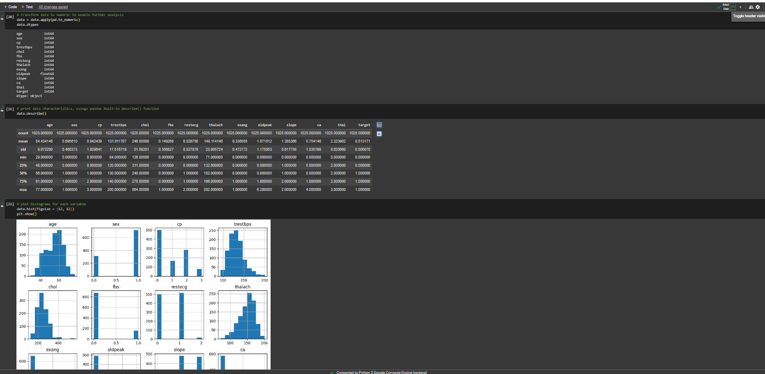

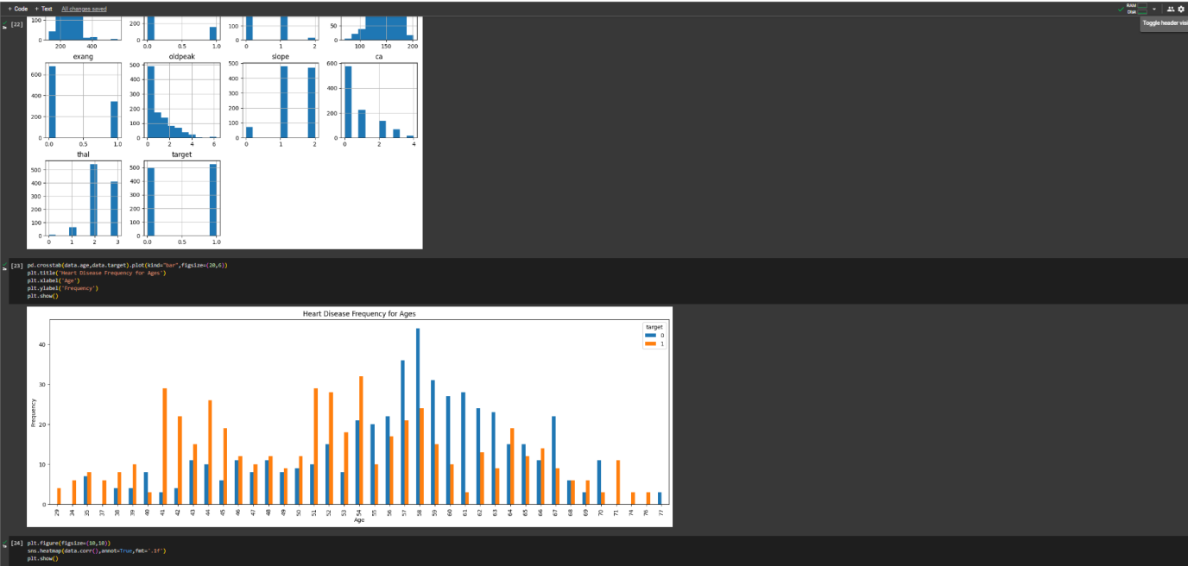

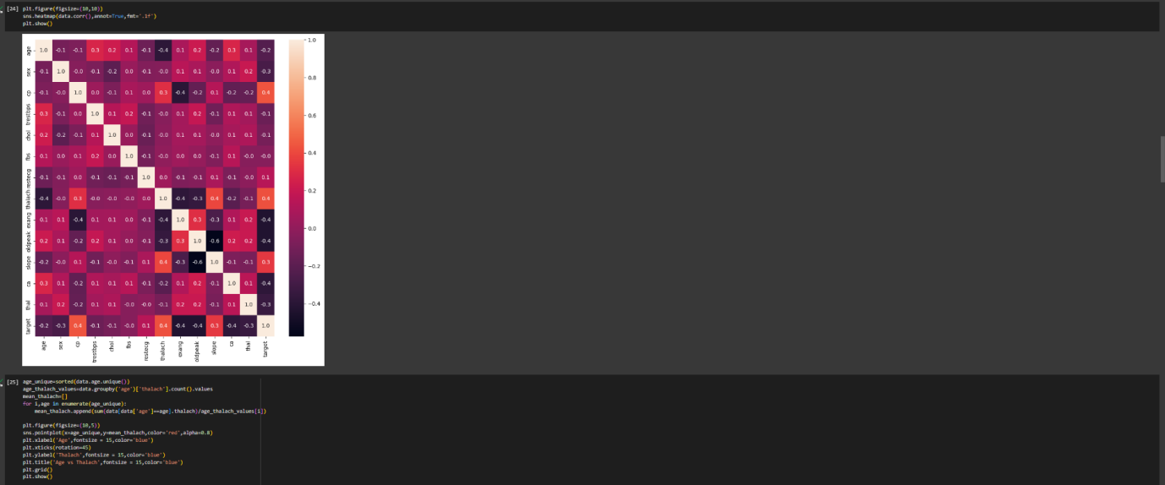

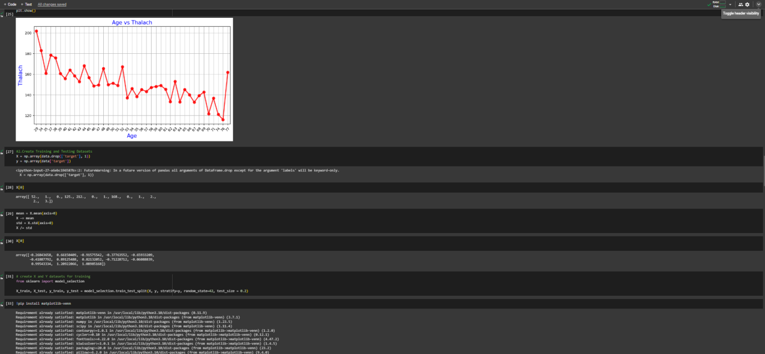

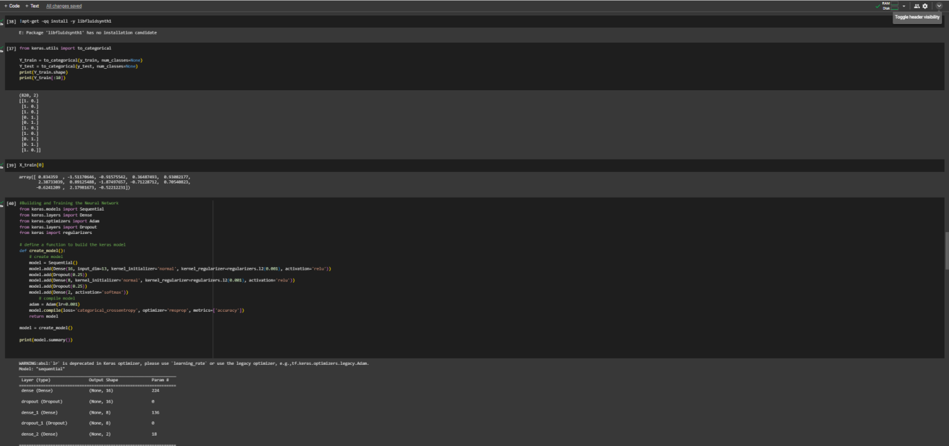

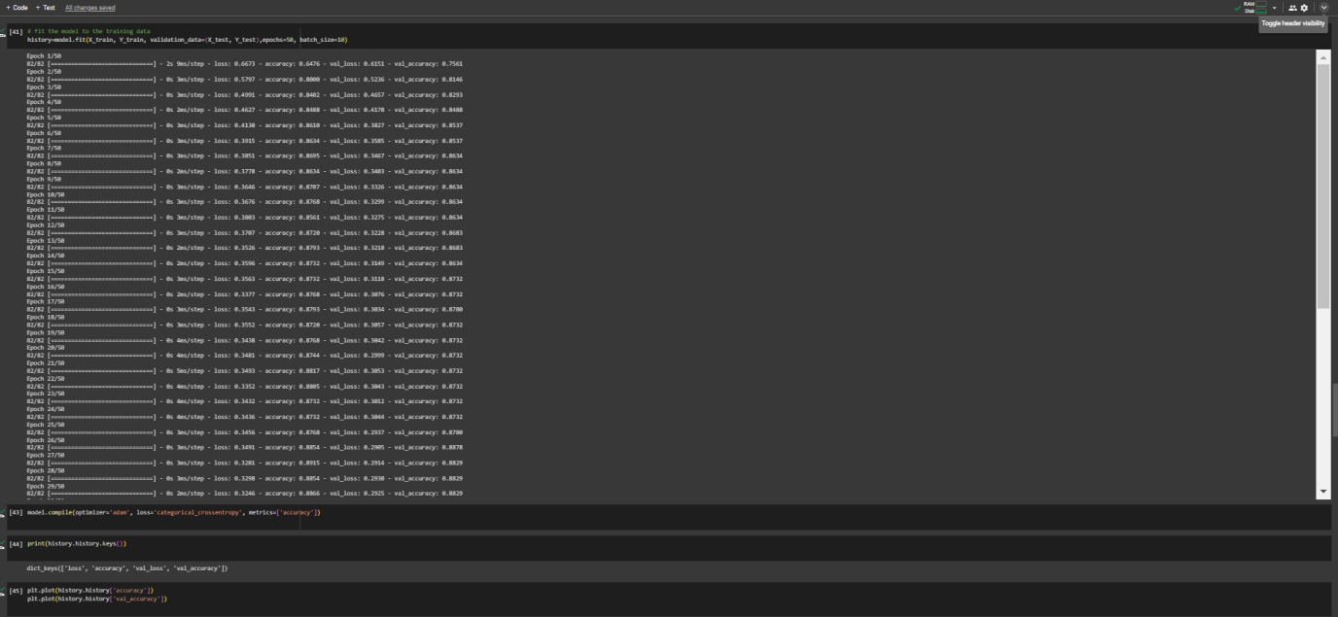

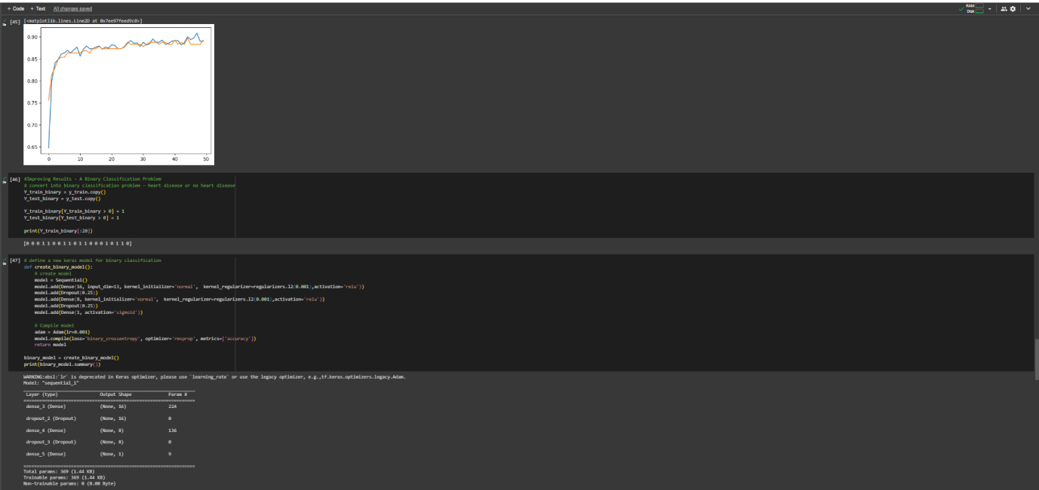

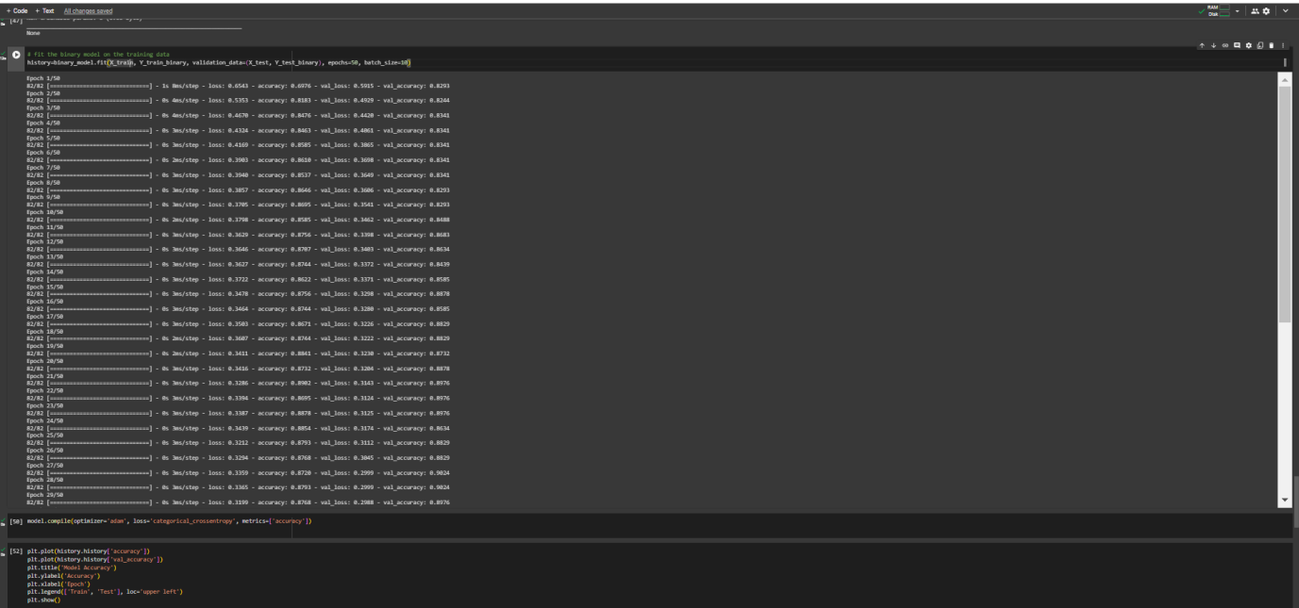

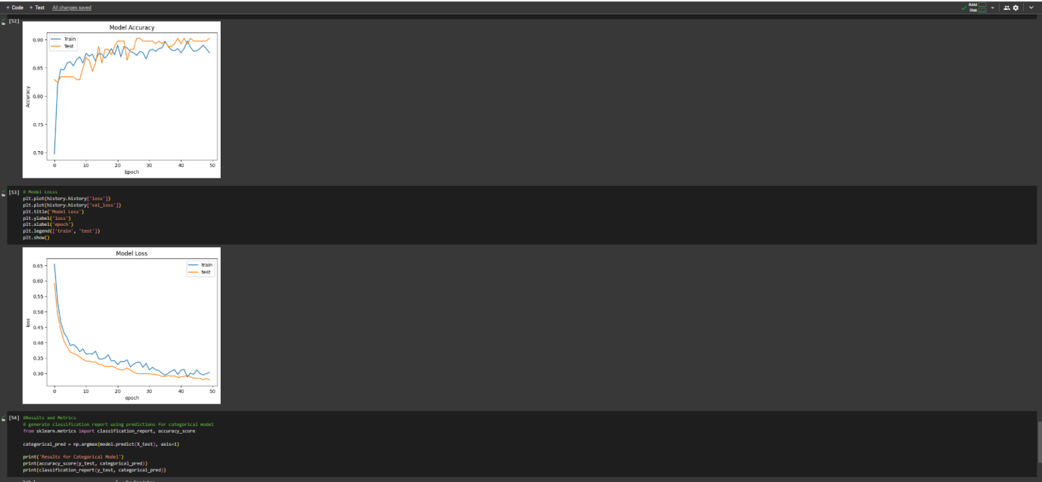

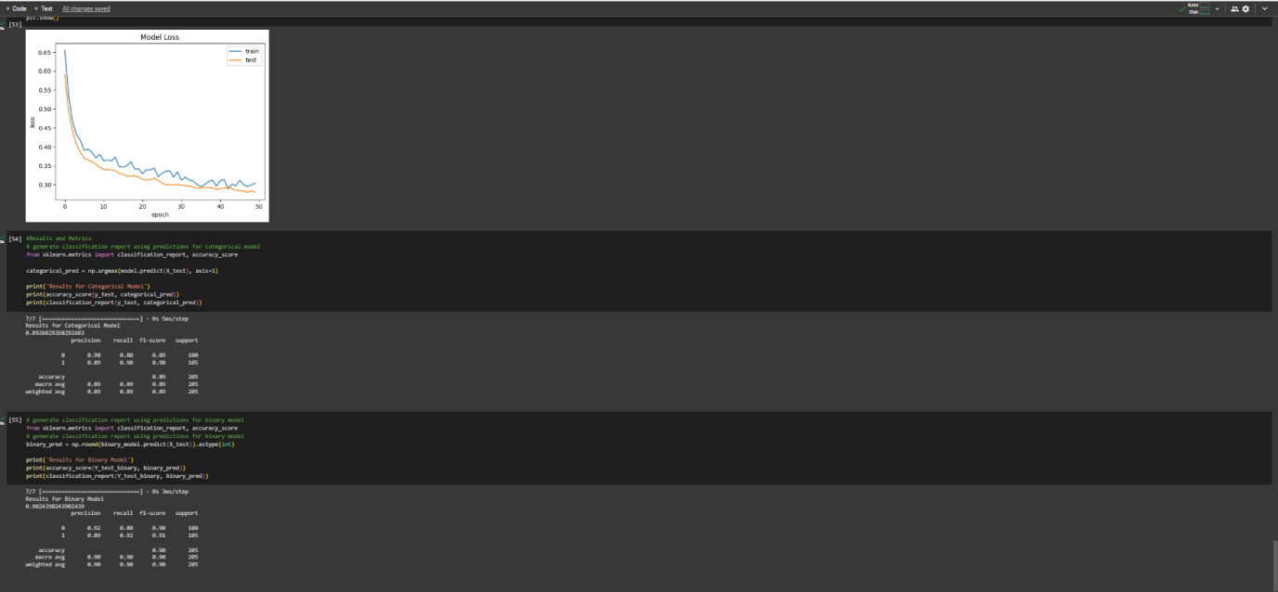

* **Google Colab Link:**

https://colab.research.google.com/drive/1QXPRA5_AhbR4pB31QYVogsDX5Wu14Qft?usp=sharing

**Conclusion:**

In conclusion, the implementation of Convolutional Neural Networks (CNNs) for predicting heart diseases represents a promising application of deep learning in healthcare. By leveraging CNNs, we can analyze complex medical data and identify patterns indicative of heart disease, enabling early detection and intervention. Despite challenges such as data quality and model performance, CNNs offer a powerful tool for improving diagnostic accuracy and patient outcomes.

Through careful selection of architecture and hyperparameters, including convolutional layers, pooling layers, and dropout mechanisms, we can optimize model performance and enhance predictive capabilities. The utilization of activation functions like ReLU further enhances the network's ability to capture nonlinear relationships within the data.

By harnessing the predictive capabilities of CNNs, healthcare providers can tailor treatment plans, facilitate personalized medicine, and implement proactive monitoring systems. This proactive approach to cardiac wellness holds the potential to revolutionize patient care, minimize risks, and ultimately save lives.

Continued research, refinement, and integration of CNN-based predictive models into clinical practice will further advance our ability to combat heart diseases, improving overall healthcare outcomes and quality of life for patients worldwide.

**Observations:**

* The CNN model demonstrated promising results in predicting heart disease based on medical attributes.
* Hyperparameter tuning significantly improved model performance, achieving higher accuracy and reliability.
* The model's ability to learn complex patterns from medical data highlights its potential for clinical applications in predicting heart disease.

**CONCLUSION:** In conclusion, the utilization of Convolutional Neural Networks for heart disease prediction shows great promise in improving early detection and personalized treatment strategies. By leveraging CNNs, healthcare providers can make more informed decisions and provide better care for patients at risk of heart disease.

**REFERENCES:**

1. Brownlee, J. (2019). "How to Develop a Convolutional Neural Network to Classify Photos of Dogs and Cats (for Beginners)." Machine Learning Mastery.
2. Chollet, F. (2017). "Deep Learning with Python." Manning Publications.
3. Rajkomar, A., et al. (2018). "Scalable and accurate deep learning with electronic health records." NPJ Digital Medicine, 1(1), 18.